
Simple Palliative Care Toolkit

Before starting assessment (RN/team triage interventions):

Screen for Palliative Care (PC)-Eligible Patients

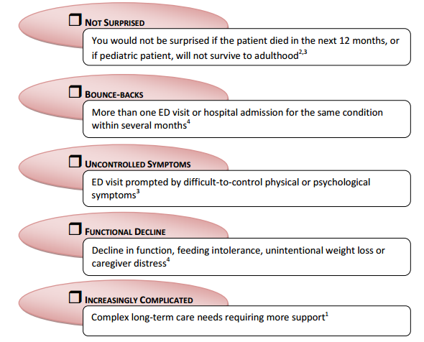
Palliative Care would benefit
all patients with a:

- Serious non-survivable illness AND

- Any of the following:

Provide Palliative Care Information to Patients Early
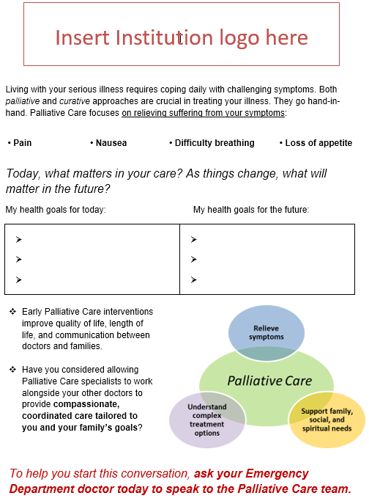

Consider providing a neutrally worded informational handout to introduce palliative care concepts and value propositions while patients are still healthy, far in advance of their terminal admission.

Download/print here: ACEP PM SECTION LINK

Point-of-care Interventions:

Manage Distressful Symptoms
SYMPTOM | DRUG TO CONSIDER | DOSE | TIPS
Pain | Opioids  [dose conversion] | 10-20% of current total daily dose for breakthrough | After 1st dose  - for moderate pain, increase 50%  - for severe pain, increase 100%.
Nausea/  Vomiting | Haldol | 0.5-2mg IV or PO | Prolongs QT –> check EKG
Dyspnea | Morphine | 2-4mg IV or 10mg PO | Unlikely to depress respiratory drive at this dose
 | Ativan | 0.5-1mg IV or PO | Second line, may worsen delirium
Delirium | Haldol | 0.5-2mg IV or PO | Search for underlying cause.
Terminal secretions | Glycopyrrolate | 0.1mg IV or 0.2mg PO | Reduces respiratory gurgling
 | Atropine 1% ophthalmic gtt | 1-2 drops sublingual

The Goals of Care (GOC) Procedure

The Five Minute ED Goals of Care Conversation
Minute 1-2 | - Elicit patient understanding of underlying illness and today’s acute change  - If available, build off previous advance directives or documented conversations  - Acquire sense of patient’s values and character (to help frame prognosis and priorities for intervention)  - Name and validate observed goals, hopes, fears, and expectations
Minute 3-4 | - Discuss treatment options using reflected language  - Continually re-center on patient’s (not family’s) wishes and values  - Recommend a course of action, avoiding impartiality when prognosis is dire
Minute 5 | - Summarize and map out next steps  - Introduce broader team of ED resources (e.g. observation unit, chaplain, social work)

Disposition (involve case management):
