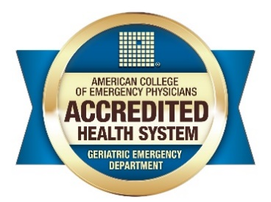
Geriatric Emergency Department Accreditation
System-Level Award

“Health System GED Accreditation”
Criteria:
- A health system can achieve this special recognition when at least 80% or 10 of their system EDs has received a GED accreditation award within the same 3-year time period.
- System leadership completion of the GED health system questionnaire.
- System GEDs join the Geriatric Emergency Department Collaborative (GEDC). https://gedcollaborative.com/

Award:
- Upon receipt of the above-mentioned questionnaire, ACEP will provide a certificate of recognition as a system leader in GEM. The certificate will be addressed to the author of the provided statement.
- ACEP will also provide each ED a new certificate that includes the above health system seal.
- Recognition plaques will be provided to the two main champions that the health system determines provided the greatest impact towards this achievement.
- ACEP will help promote this achievement through its channels.

Submissions/Questions:
Nicole Tidwell
Senior Accreditation Program Manager
American College of Emergency Physicians / Advancing Emergency Care
Direct: 469-499-0149
https://www.acep.org/GEDA
ntidwell@acep.org

